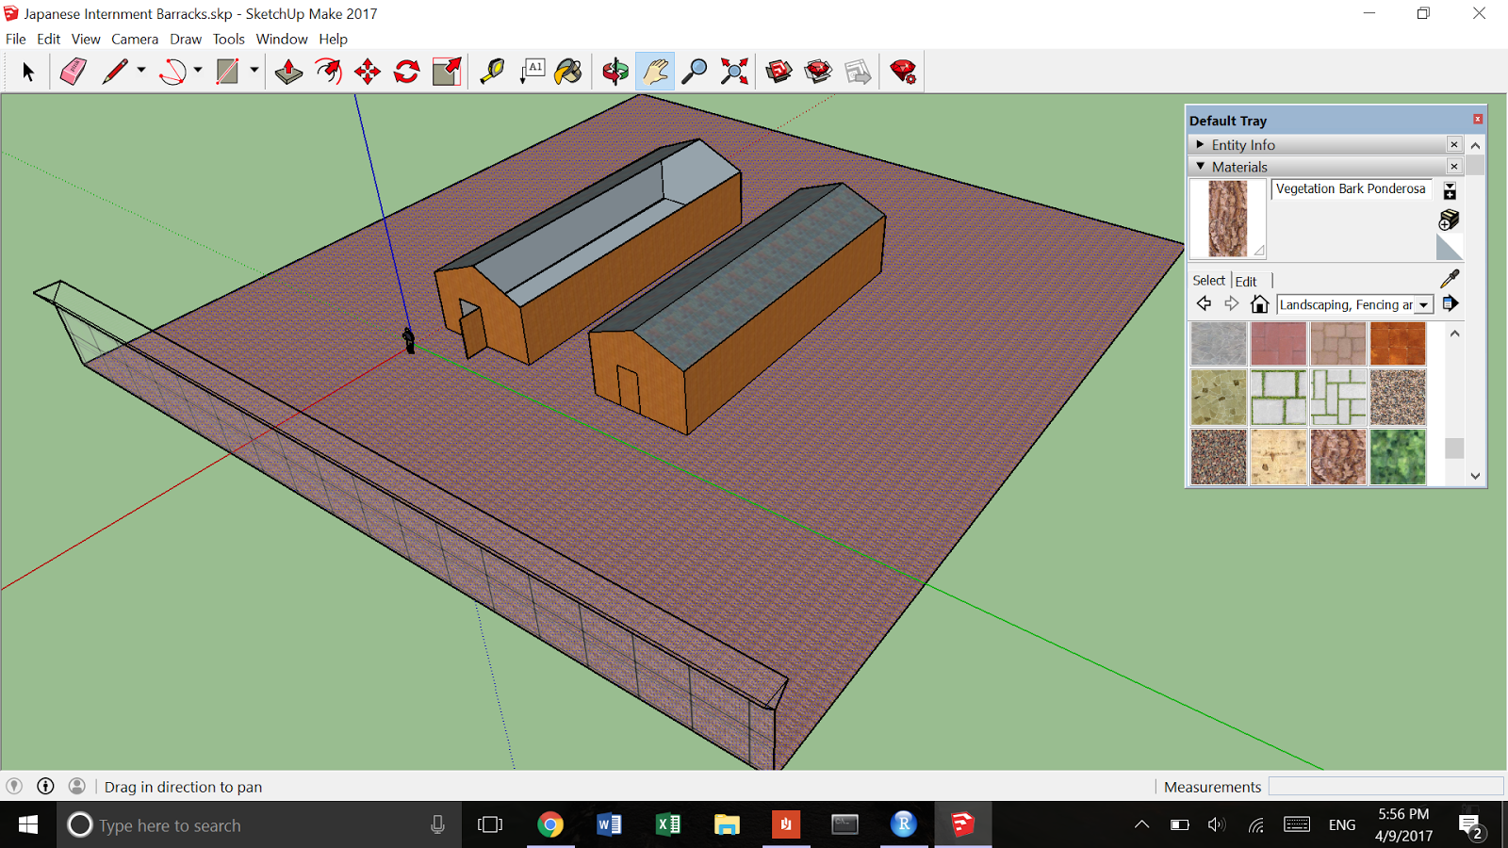

Tutorial:

1. **Getting Started**
   1. **Open SketchUp and use either of the “Simple Templates”**
   2. **Changing the perspective**:
      1. Camera -> (1) Parallel Projection, (2) Perspective, (3) Two-Point Perspective
      2. Use the Orbit tool to have a 360 degree view of the models, Zoom tool to zoom in and out, and the Pan tool to drag horizontally and vertically
2. **Create rectangular buildings**:
   1. Draw rectangles for each wall, using Shapes -> Rectangles (“Shapes” is the tool on the menu, left of “Push/Pull”)
   2. Draw one rectangle as the base: Shapes -> Rectangles and use the Push/Pull tool to drag the rectangle upwards to create a 3D object
   3. Use the Lines tool to create a door
   4. Note: When you are drawing shapes and lines, pay attention to the color of the indicator -- it will tell you which dimension you are working in.  Holding shift while you drag will keep your shape/line on the same plane.
3. **Add a triangular roof**:
   1. Use the Lines tool to find the midpoint of the building/rectangular face and drag up to draw a straight line. Connect the two endpoints of the rectangular face to the newly drawn endpoint from the midpoint line to create a triangular face above the rectangular face. From the midpoint line endpoint, draw another parallel line to the end of the building to create the second triangular face. Lastly, use the Eraser tool to erase unnecessary lines that helped guide your sketch.
4. **Change the texture of objects**:
   1. From the Paint Bucket tool, we can use the drop down menu from the Materials section of the Default Tray to select the appropriate material. For example, we can choose Roofing -> Roofing Slate Black and Wood -> Wood Bamboo to fill in the texture of the roofing and walls respectively.
5. **Create a fence**:
   1. Created a rectangular wall and fill it in with Landscaping, Fencing and Vegetation -> Fencing Metal Straight
   2. Use the Lines tool to draw an upside down triangular prism and fill it in with Landscaping, Fencing and Vegetation -> Fencing Metal Wire
6. **Fill in the ground material**:
   1. Draw a rectangular plot on the axis underneath the buildings
   2. Fill in the rectangle with Landscaping, Fencing and Vegetation -> Vegetation Ponderosa Bark to imitate the rough, barren terrain

